**LAB 10 (INTRODUCTION TO NODE JS)**

**TASK 1**

Write a node js program to create a server successfully and print the greeting as the server response message to client.

**CODE**

const http = require('http')

const hostname = '127.0.0.1'

const port = 3001

const server = http.createServer((req, res) => {

  res.statusCode = 200

  res.setHeader('Content-Type', 'text/plain')

  res.setHeader("content-type",'text/html')

  res.end('<h1>Greetings From Shah</h1>')

})

server.listen(port, hostname, () => {

  console.log((`Server running at http://${hostname}:${port}/`))

})



**OUTPUT**

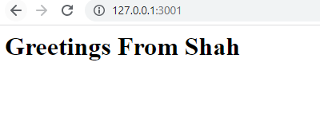

**TASK 2**

Write a node js program to create a server and read the query string and print the server response by using the object property called "url" which holds the part of the url that comes after the domain name.

**CODE**

const http = require('http')

const hostname = '127.0.0.1'

const port = 3000

const server = http.createServer((req, res) => {

  const query = req.url.substring(1,req.url.length);

  res.setHeader('Content-Type', 'text/html')

  res.write(`<h3>${query}</h3>`)

})

server.listen(port, hostname, () => {

  console.log(`Server running at http://${hostname}:${port}/`)

})

**OUTPUT**

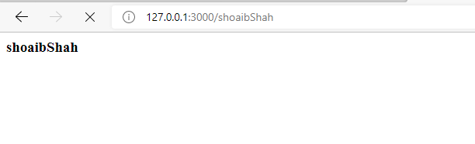

**TASK 3**

Write a node js program to create an object of your personal details and with the help of built-in functions, print those details as the server response in the form of string.

**CODE**

const biodata = {

    name: "Syed M Shoaib",

    section: "A",

    department: "Software Engineering",

    semester: "6"

};

const jsonData = JSON.stringify(biodata);

const objData = JSON.parse(jsonData);

const http = require('http')

const hostname = '127.0.0.1'

const port = 3000

const server = http.createServer((req, res) => {

    res.statusCode = 200

    res.setHeader('Content-Type', 'text/html')

    res.end('<h1><center>'+jsonData+'</center></h1>')

    res.end('<h1><center>'+objData+'</center></h1>')

  })

  server.listen(port, hostname, () => {

    console.log(`Server running at http://${hostname}:${port}/`)

  })

**OUTPUT**

